Application Deployment

* Install git in ec2 instance and check version

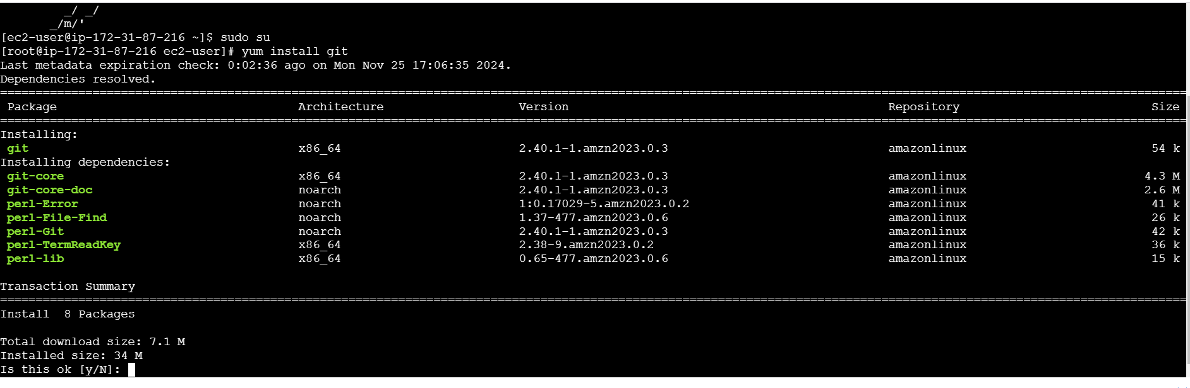

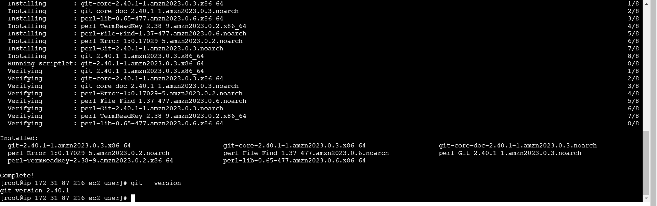

* Install docker image in ec2 instances and check version

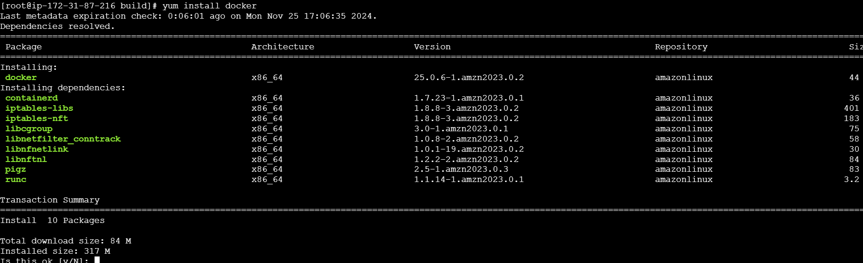

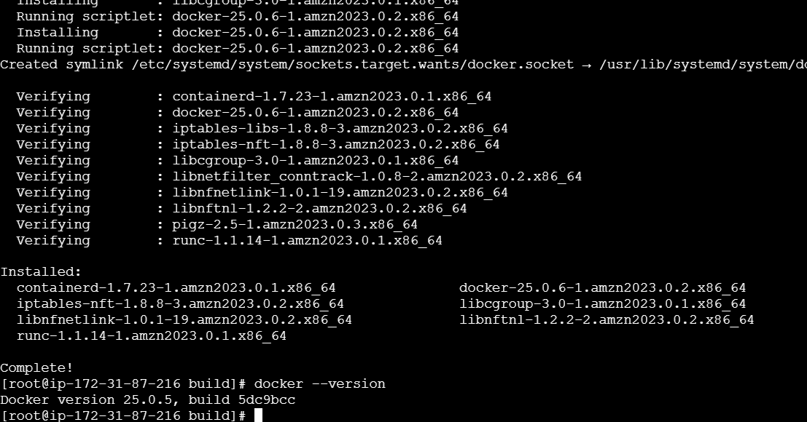

* After use git clone command to pull code from remote repo

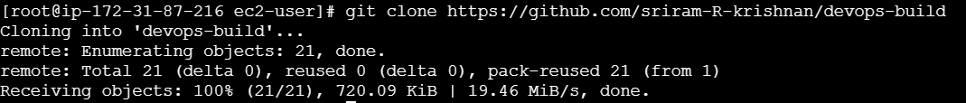

* Complete the pull afterward create a dockerfile for the application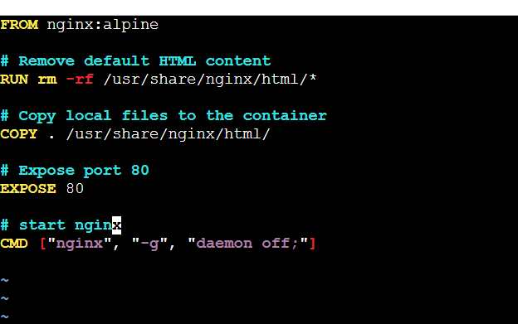
* Use command run dockerfile

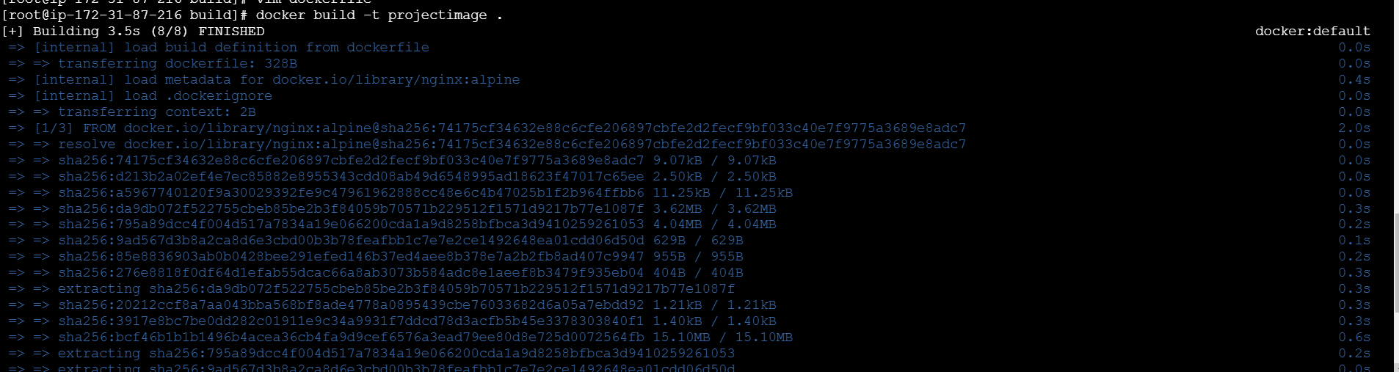

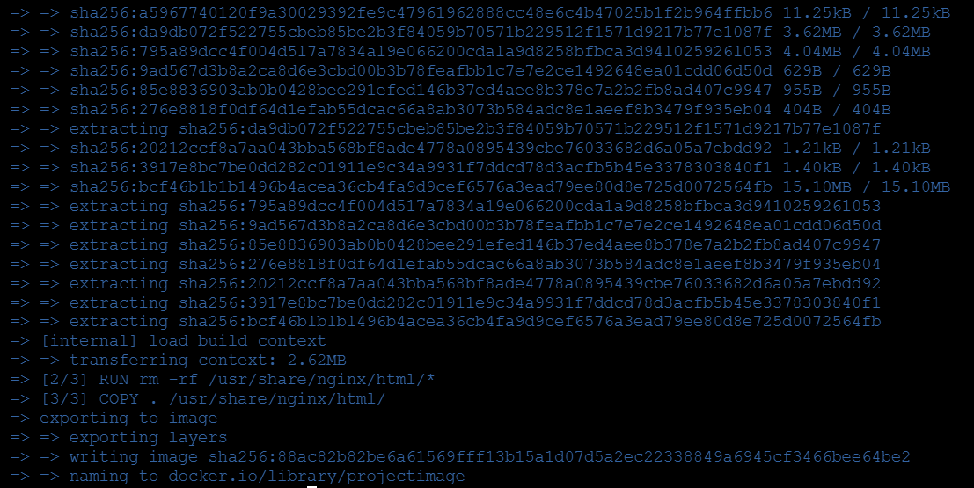Successfully its run by using command

* After create docker-compose file for the application

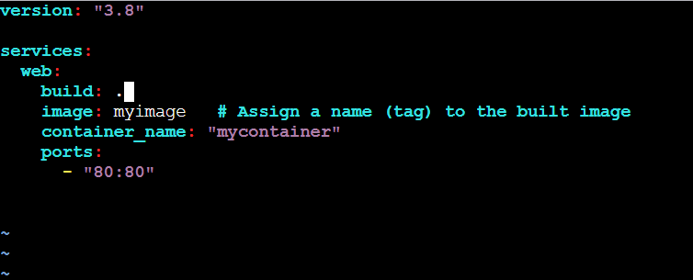

Run docker-compose file now

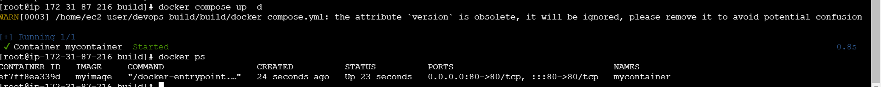

Finally its also completed successfully

* Create a build.sh file to build image

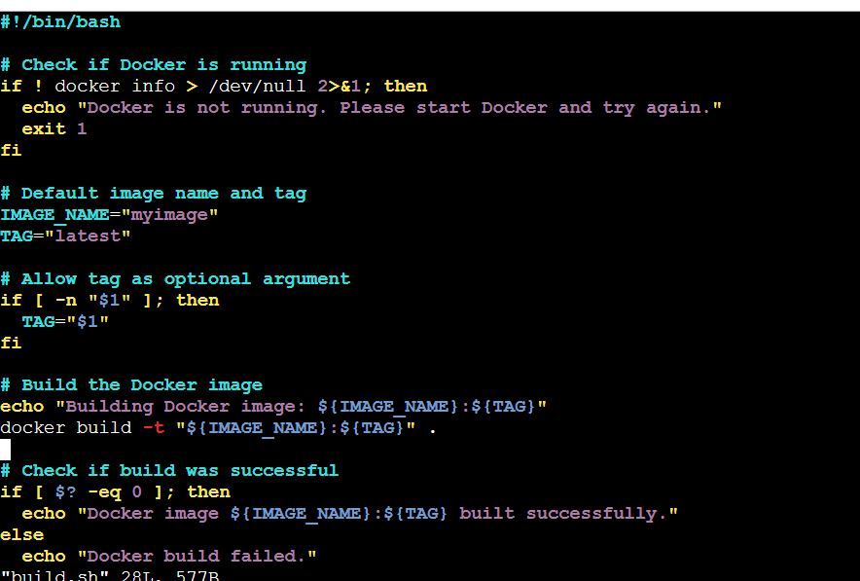

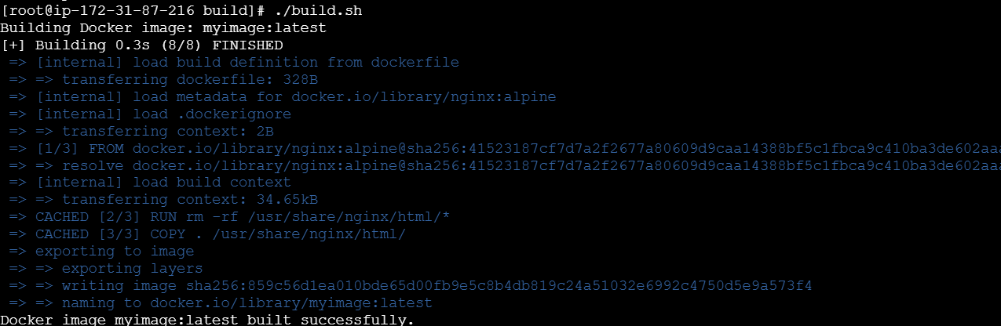

After create a deploy to dockerhub

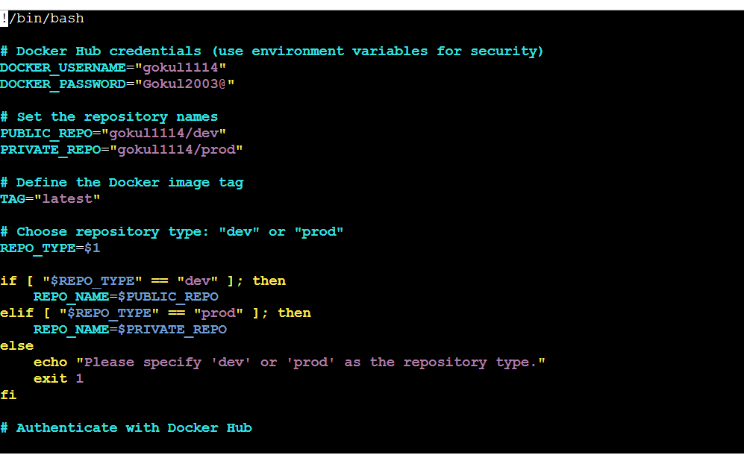

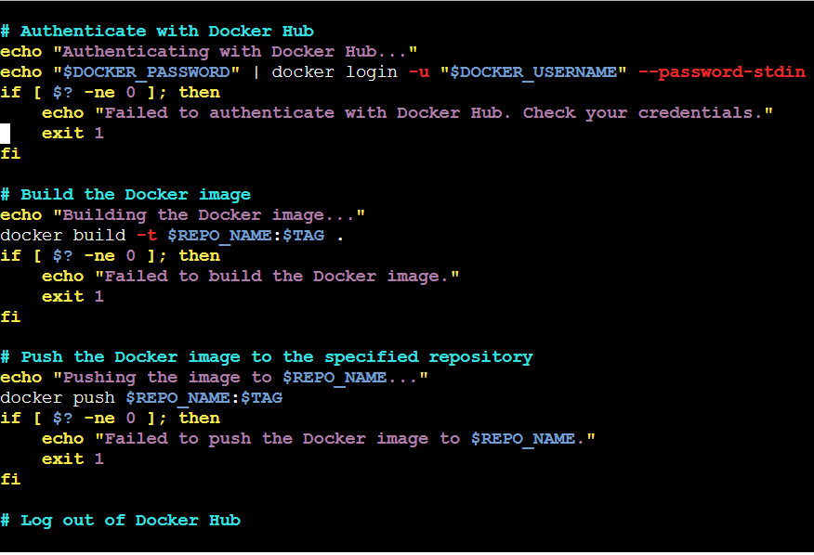

* Now push the code to github

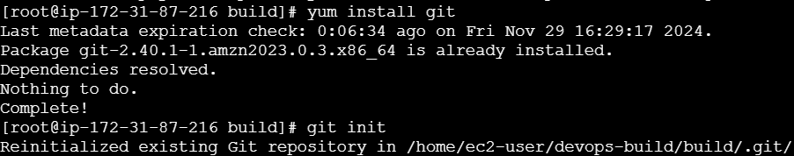

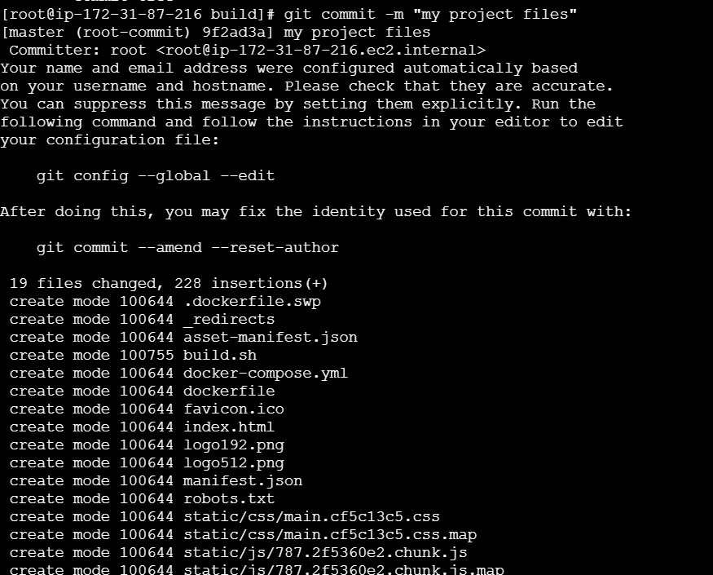

Use classic token to github password

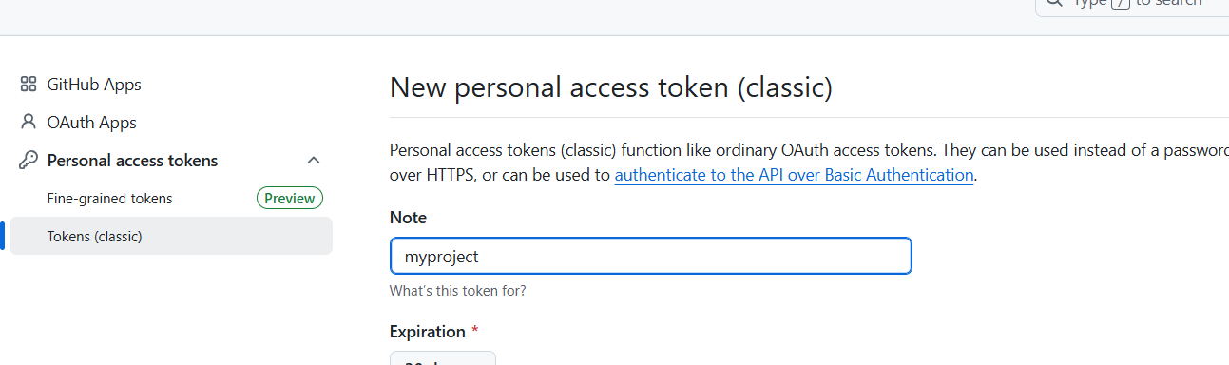

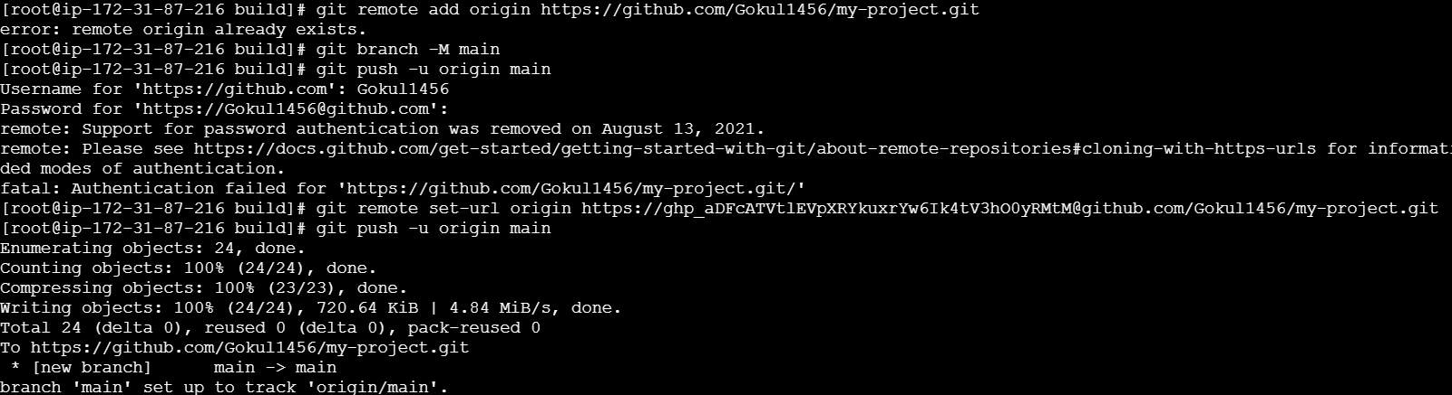

Now create branch “ dev”

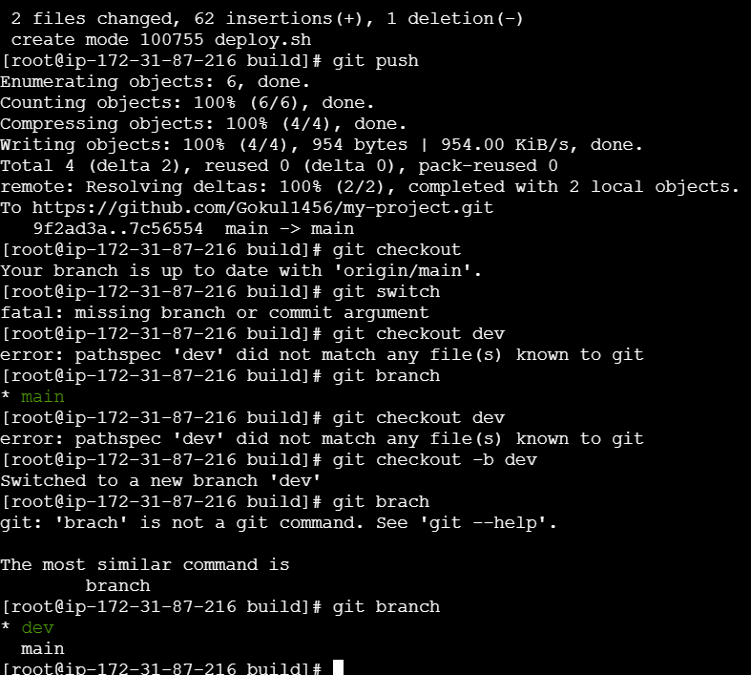

Finally creat dev branch and push the code

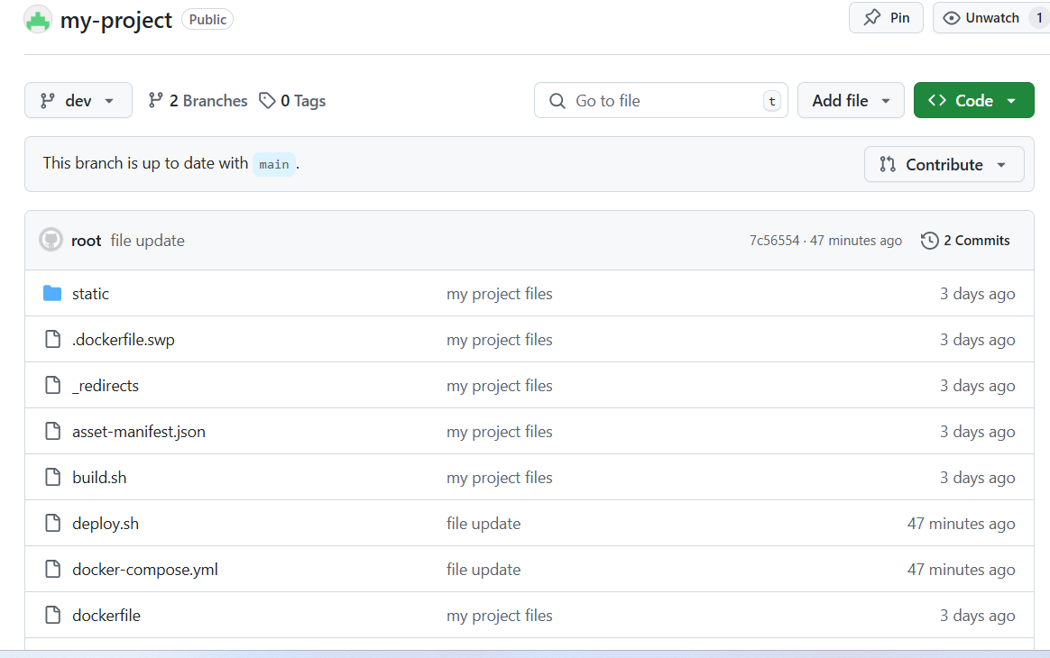

* Now create a dockerhub but already make command in deploy file when the deploy file will run automatically create a dockerh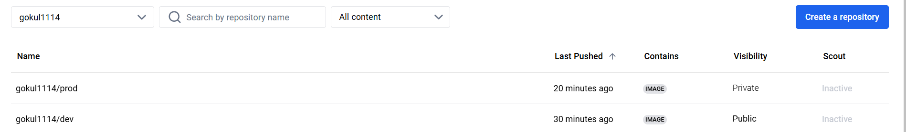
* Login Jenkins website

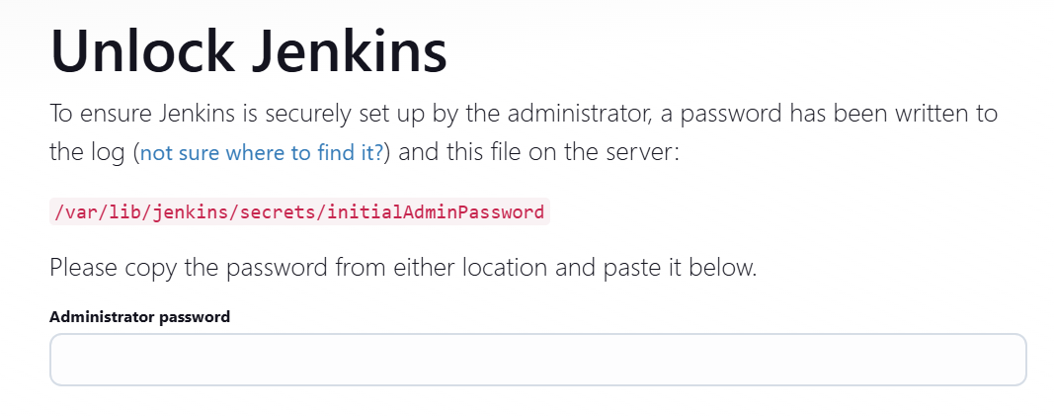

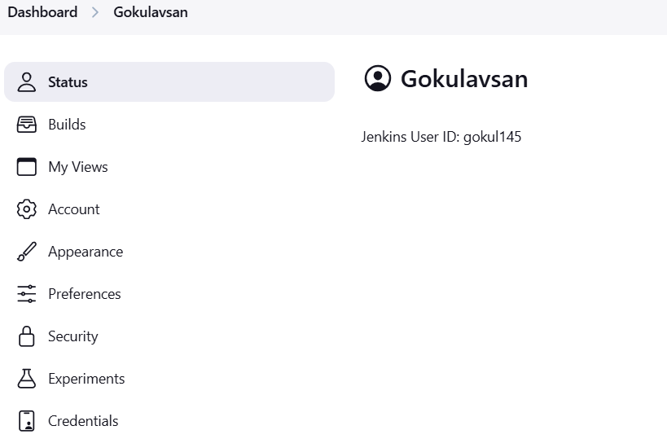

Create item name and select a muiltbranch pipline and save afterward

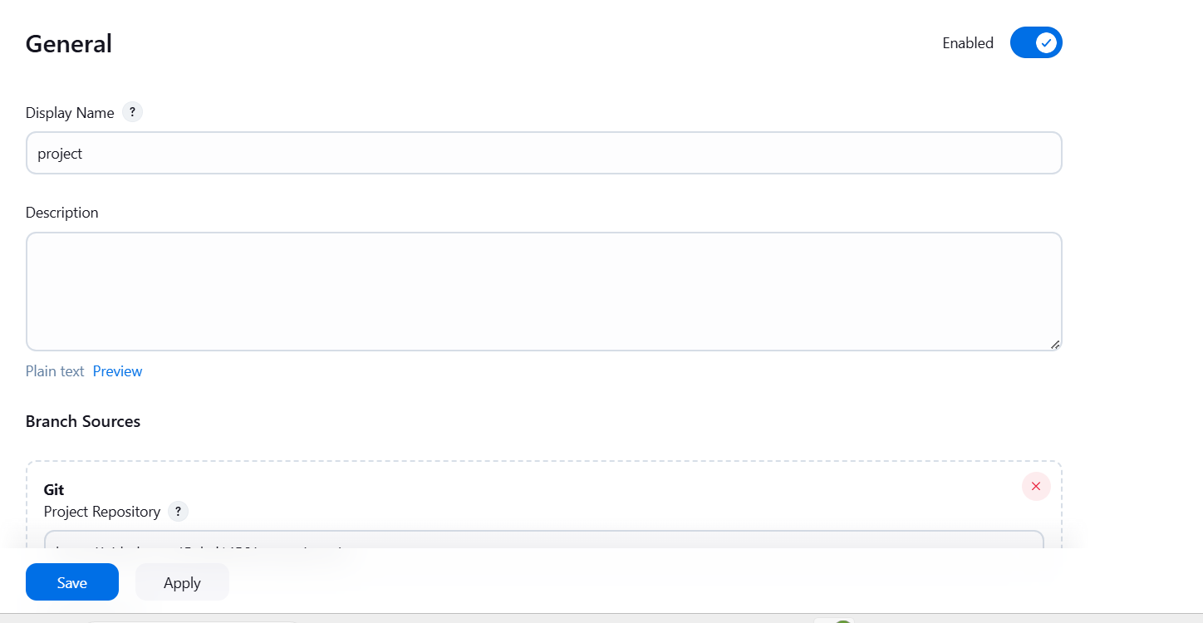

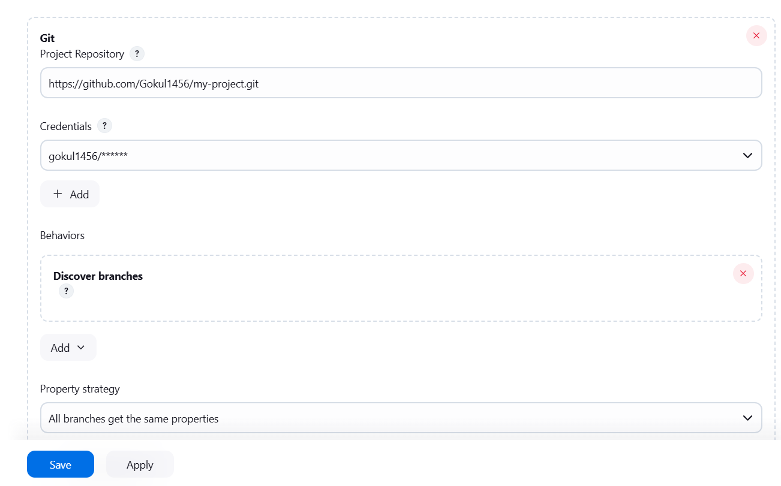

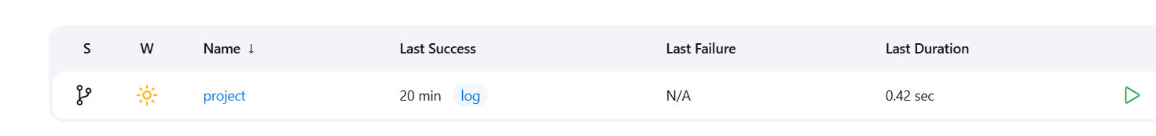

Successfully running the pipline

Inside a project

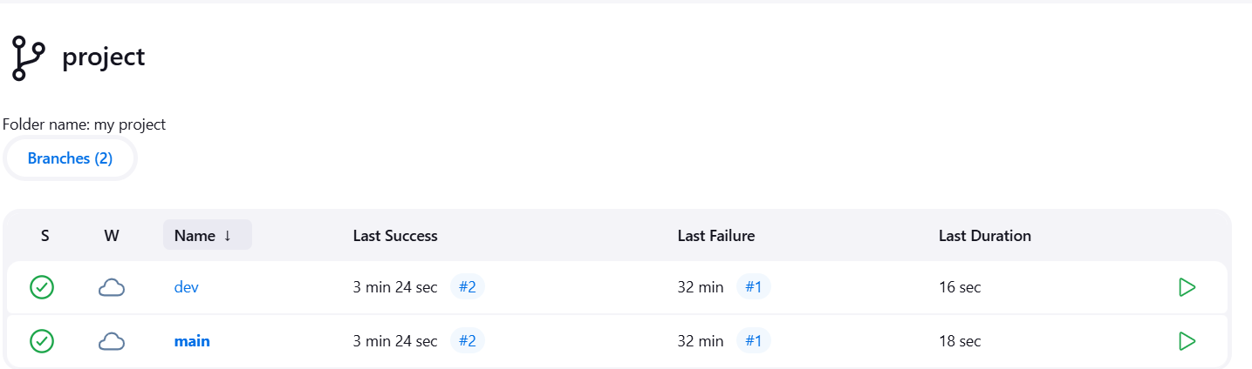

Console output

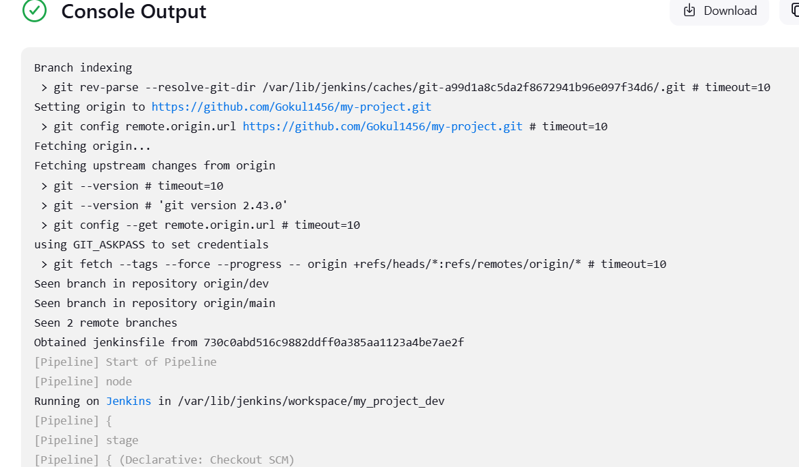

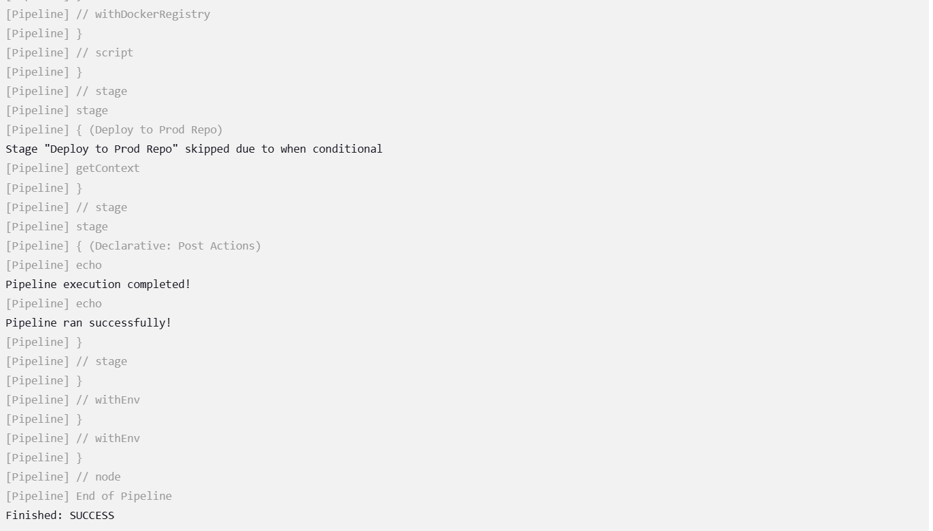

Both branch are successfully running in Jenkins.

* AWS INSTANCES

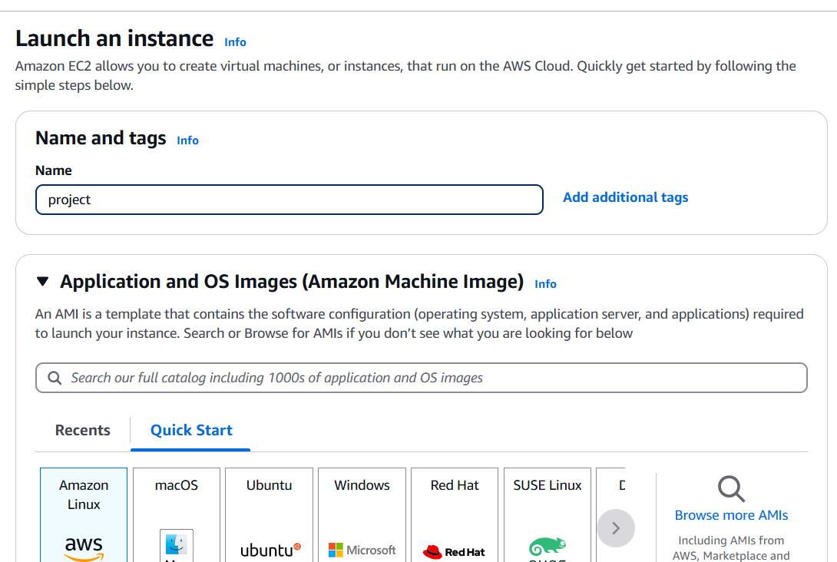

Creata as a project

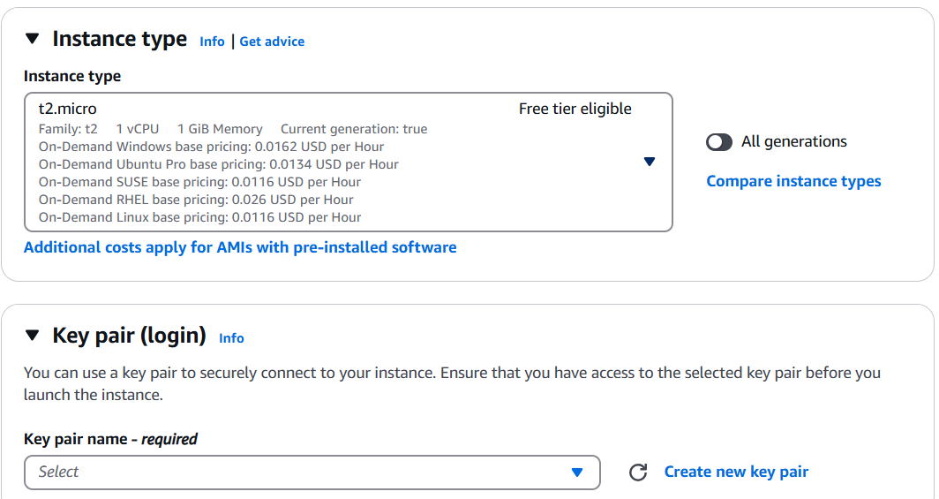

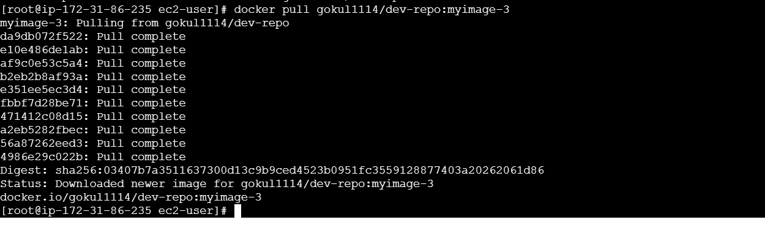

After pull the command from dockerhub successfully its install

Use the ip address to explore the page

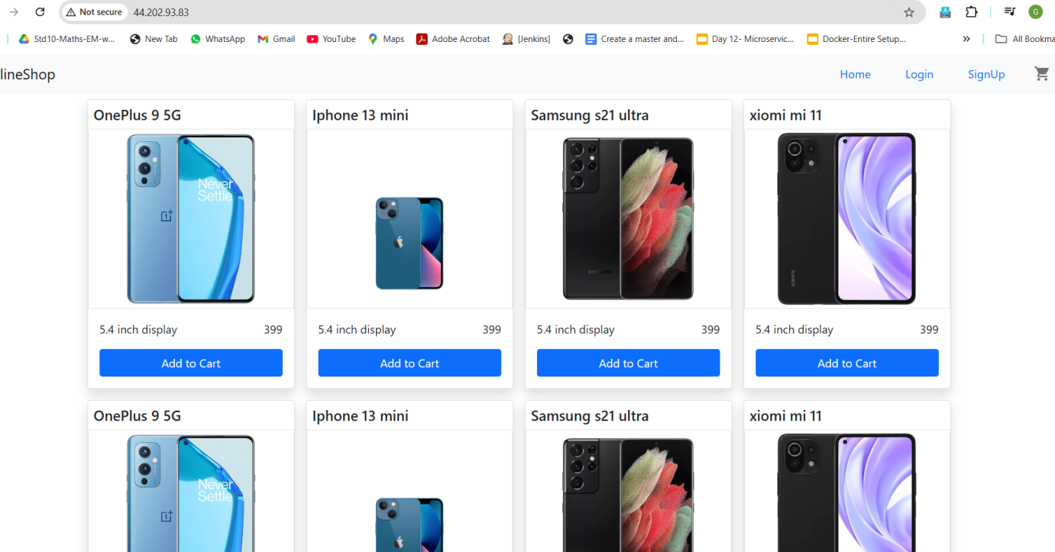

Monitoring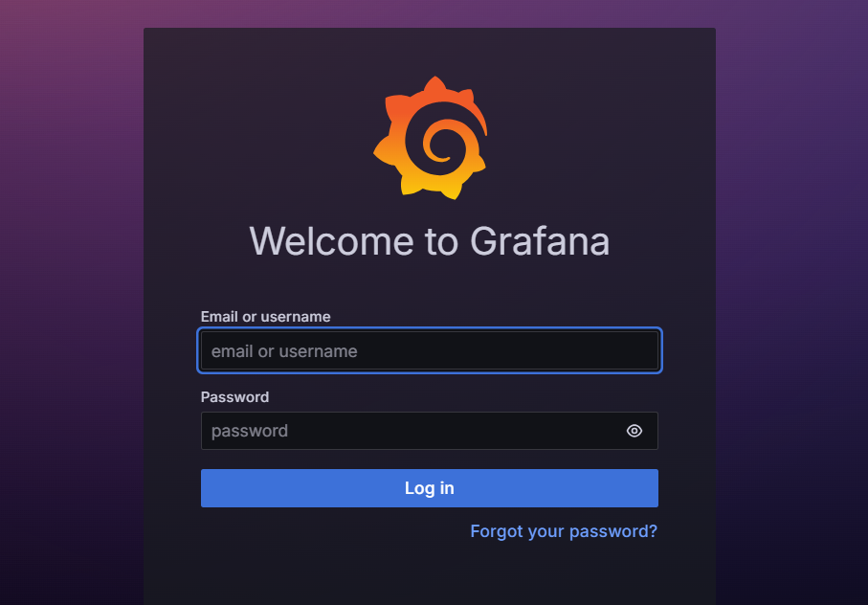

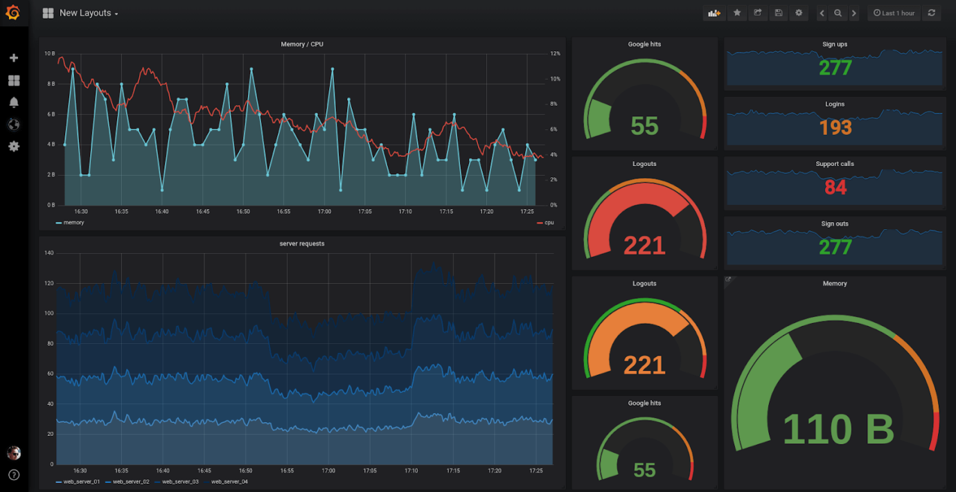

Source code link : <https://github.com/Gokul1456/my-project.git>